Poly Furniture 3/20/2026
Chairs | Standard Colors | Premium Colors
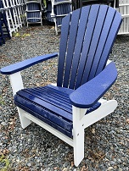  Non-Folding Adirondack | $239 | $279
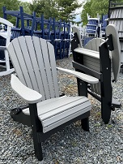  Folding Adirondack | $279 | $319
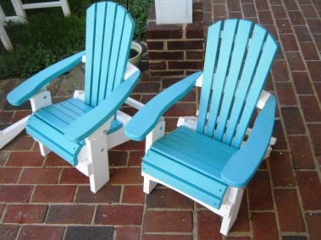  Child’s Adirondack  Dining or Folding | $179 | $179
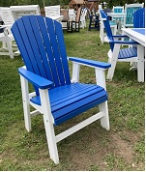  Adirondack Dining | $269 | $309
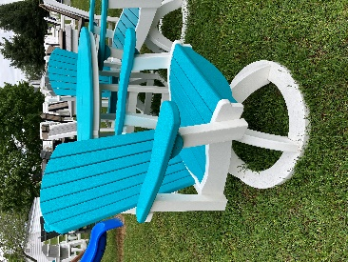  Swivel Adirondack Dining | $549 | $599

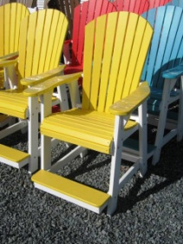  Café Adirondack Arm Chair (24” to seat)  (Arm Chairs Only) | $379  Bar Ht. 30” - $416  Custom order only | $409  Bar Ht. 30” - $449  Custom order only
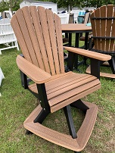  Swivel Café Adirondack Arm Chair (24” to seat) | $549  Bar Ht. 30” - $604  Custom order only | $599  Bar Ht. 30” - $659  Custom order only
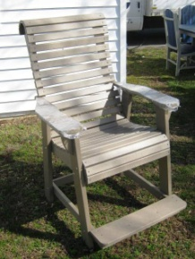  Café Rollback Arm Chair  (24” to seat)  (Arm Chairs Only)  Up to 16 weeks for Rollback orders | $379  Bar Ht. 30” - $416  Custom order only | $409  Bar Ht. 30” - $449  Custom order only

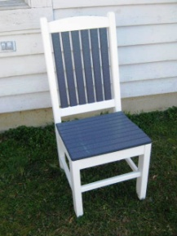  Mission Dining Side Chair  (Add $50 for Arms) | $199 | $239
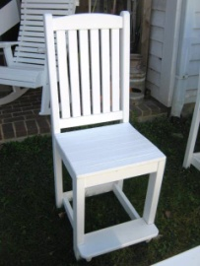  Mission Café Side Chair  (Add $50 for Arms) | $249 | $279
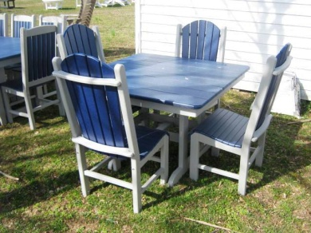  Fanback Dining Side Chair  (Add $50 for Arms) | $239 | $269
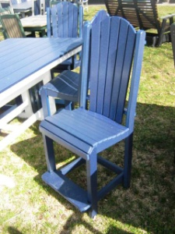  Fanback Café Side Chair  (Add $50 for Arms) | $279 | $309
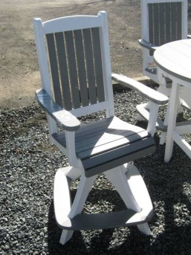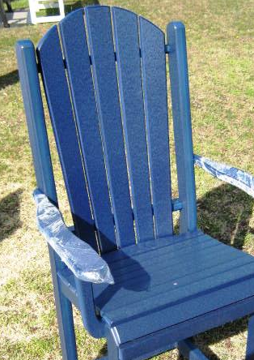  Swivel Mission or Fanback Café Arm Chair | $499 | $549

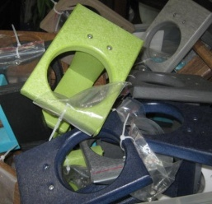  Cup Holders | $14 | $16

Settee’s | Standard Colors | Premium Colors
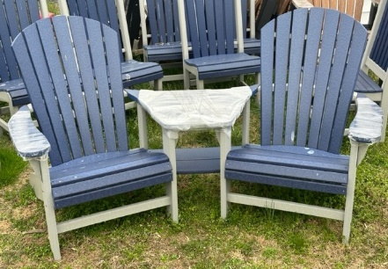  Adirondack Settee | $699 | $799
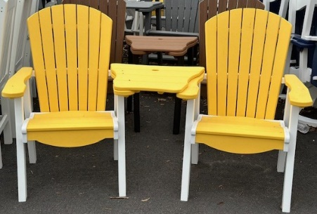  Dining Height Settee | $799 | $899
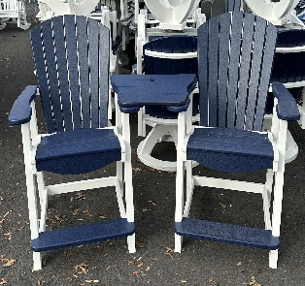  Café Height Settee | $899 | $999

Surfboard Table and Matching Stools | Standard Colors | Premium Colors
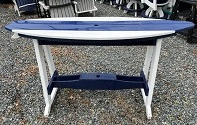  6 ft. Surfboard Table  70”L X 22”W X 39”H | $699 | $749
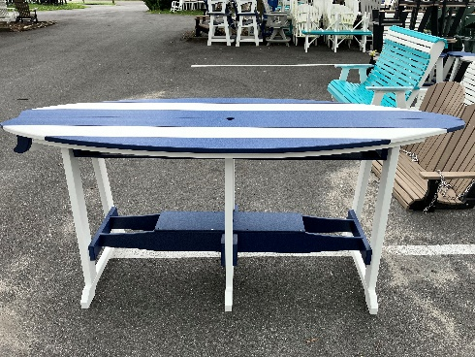  8 ft. Surfboard Table  92”L X 32”W X 39”H | $1299 | $1399
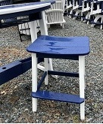  Surfboard Saddle Stool | $219 | $239
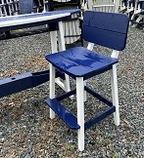  Surfboard Saddle Stool with Back | $249 | $269

Bars and Stools | Standard Colors | Premium Colors
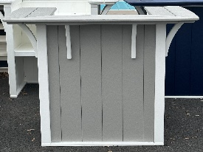  Grand Bar  42”H X 46”W X 32”D  Discontinued  As stocked only | $1099 | $1199
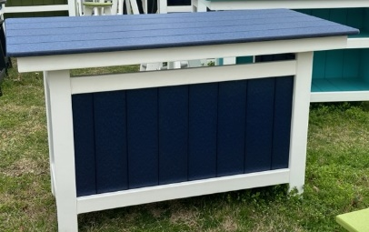  Serving Bar  36”H X 58”W X 28”D | $999 | $1099
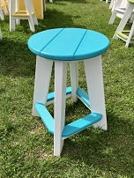  Round Counter Stool  (24” or 30”) | $179 | $199

Cabo and Farmhouse Chairs | Standard Colors | Premium Colors
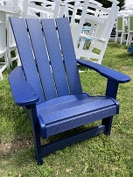  Cabo Adirondack | $259 | $289
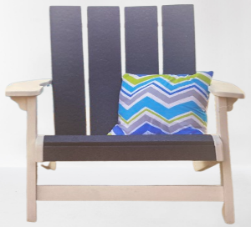  Cabo Dining Chair | $329 | $359
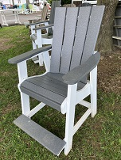  Cabo Café  Adirondack Chair | $369 | $399
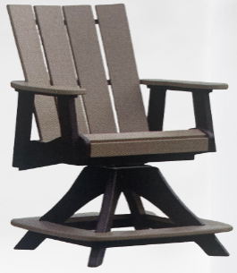  Cabo Café  Adirondack Swivel Chair | $549 | $599

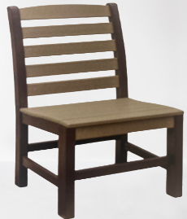  Farmhouse Dining Side | $229 | $249
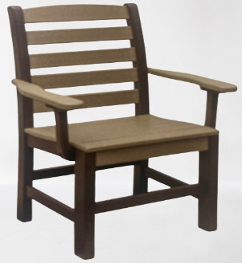  Farmhouse Dining Side  w/ Arms | $279 | $299
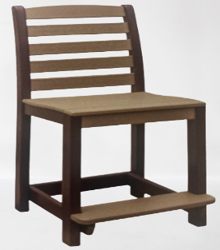  Farmhouse Café Side | $269 | $299
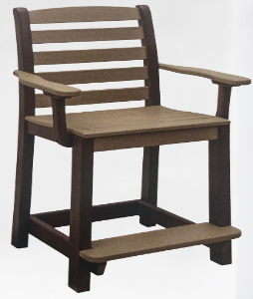  Farmhouse Café Side  w/ Arms | $319 | $349

Picnic Tables | Standard Colors | Premium Colors
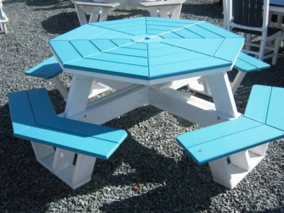  Octagon Picnic Table | $1499 | $1699
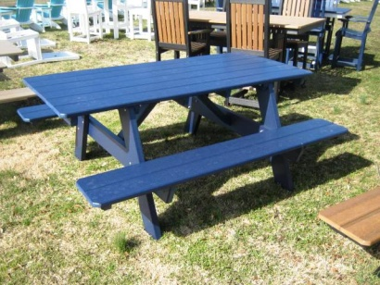  32x72 Attached Bench | $999 | $1199
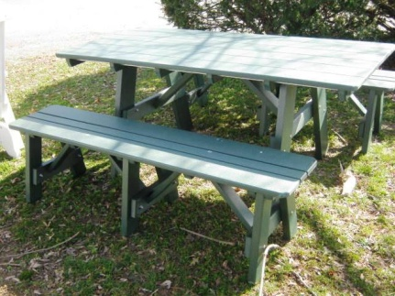  Separate w/ 2 Benches | 32x72 $1299  32x96 $1599 | 32x72 $1499  32x96 $1799
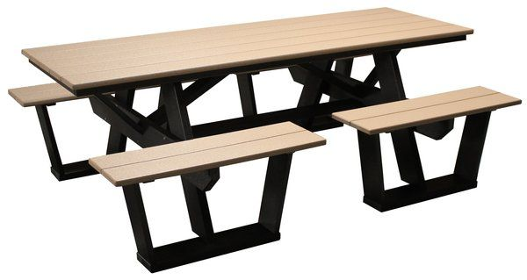  Split Bench Table  84” Long | $1199 | $1399
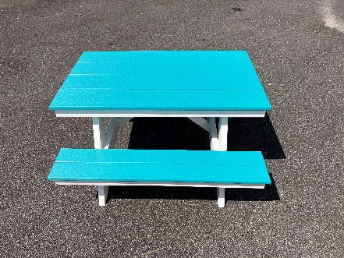  Child’s Picnic Table  36” L X 22” W X 20” H | $359 | $379

Tables | Standard Colors | Premium Colors
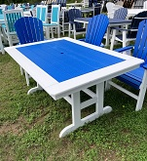  Square/Rectangular  Dining Table | 44x44” $699  44x64” $899  44x72” $999  44x84” $1099  44x96” $1199  44x120” $1399  (Same price for plank or border tops) | 44x44” $799  44x64” $999  44x72” $1149  44x84” $1249  44x96” $1399  44x120” $1599  (Same price for plank or border tops)
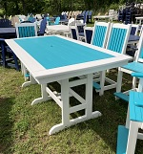  Square/Rectangular  Café Table | 44x44” $799  44x64” $999  44x72” $1099  44x84” $1199  44x96” $1299  44x120” $1499  (Same price for plank or border tops)  Bar Ht. add $50 | 44x44” $899  44x64” $1099  44x72” $1249  44x84” $1349  44x96” $1499  44x120” $1699  (Same price for plank or border tops)  Bar Ht. add $50

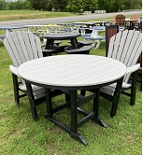  Round Dining Table | 42” $599  48” $699  (44½” sold at 42” price,  no re-orders)  Bar Ht. add $50 | 42” $699  48” $799  (44½” sold at 42” price,  no re-orders)  Bar Ht. add $50
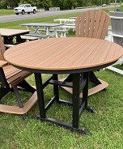  Round Café Table | 42” $699  48” $799  (44½” sold at 42” price,  no re-orders)  Bar Ht. add $50 | 42” $799  48” $899  (44½” sold at 42” price,  no re-orders)  Bar Ht. add $50
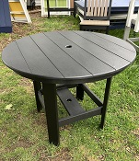  38” Round Straight Leg Table  No reorders | Dining $399  Café $499 | Dining $449  Café $549
32” Round Straight Leg Table | 21” Ht. $369  29” Ht. $409  34” Ht. $449 | 21” Ht. $399  29” Ht. $439  34” Ht. $479
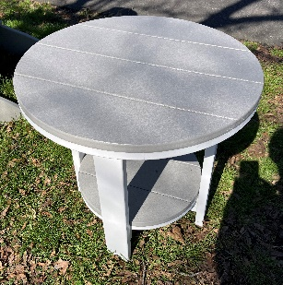  22” Round End Table  No reorders | 21” Ht. $189  29” Ht. $199  34” Ht. $209  27½” Tables sold at  22” price | 21” Ht. $209  29” Ht. $219  34” Ht. $229  27½” Tables sold at  22” price

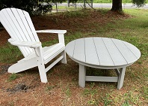  Conversation Table | $399  38” Wide X 18” High | $439  38” Wide X 18” High
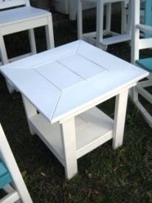  Meadowview Side Table | $229  Café Height  $269 | $249  Café Height  $289
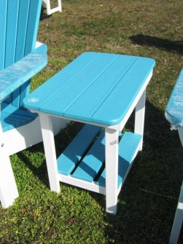  Stoney Side Table | $119 | $129
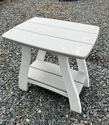  Noble Side Tables | $229  Café Height  $269 | $249  Café Height  $289
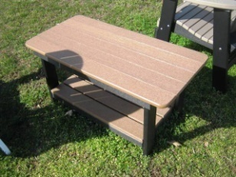  Coffee Table 18”x32”X18H | $279 | $319
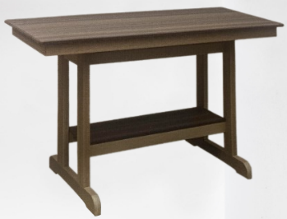  Serving Counter Table  28”x58”x36H | $599 | $699

Poly Furniture
Swings, Gliders, Rockers, & more… | Standard Colors | Premium Colors
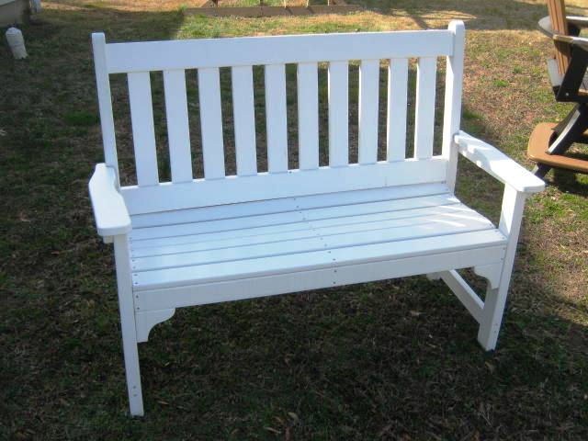  Garden Bench (4’) | $450  Fanback $100 More | $499  Fanback $100 More
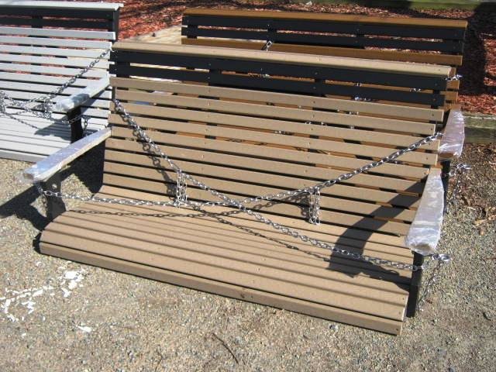  Rollback Swing  Up to 16 weeks for Rollback orders | 4 Foot $549  5 Foot $599 | 4 Foot $599  5 Foot $649
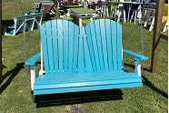  Adirondack Swing | $599  Measures 53” | $649  Measures 53”
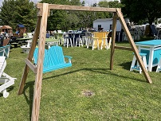  Wooden A-Frame | $369
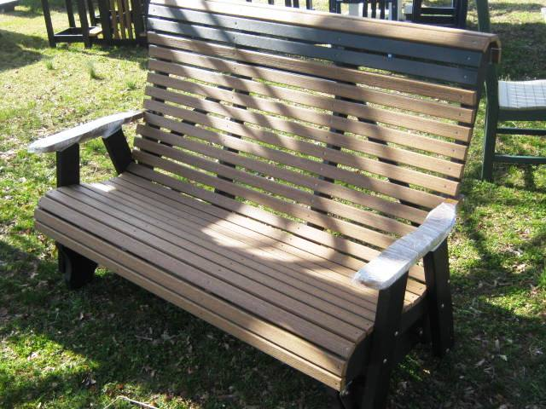  Rollback Glider  Up to 16 weeks for Rollback orders | 4 Foot $699  5 Foot $799 | 4 Foot $799  5 Foot $899
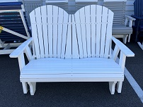  Double Adirondack Glider | 48” $699  60” w/console $899 | 48” $769  60” w/console $999
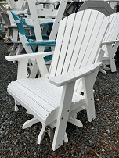  Swivel Glider Chair | $629 | $649
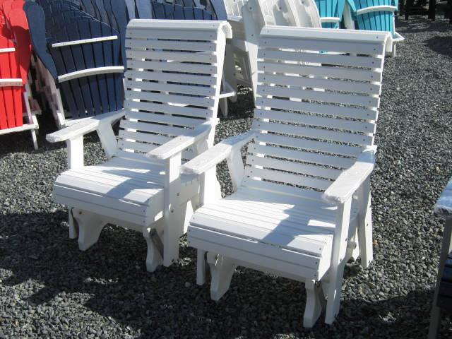  Rollback Glider Chair  Up to 16 weeks for Rollback orders | $499 | $549

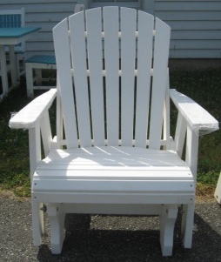  Adirondack Glider Chair | $449 | $499
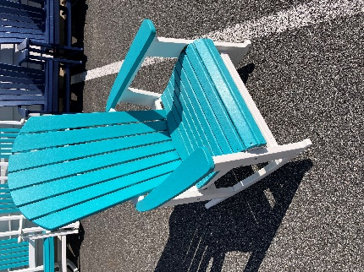  Adirondack or Rollback Rocker  Up to 16 weeks for Rollback orders | $329 | $349
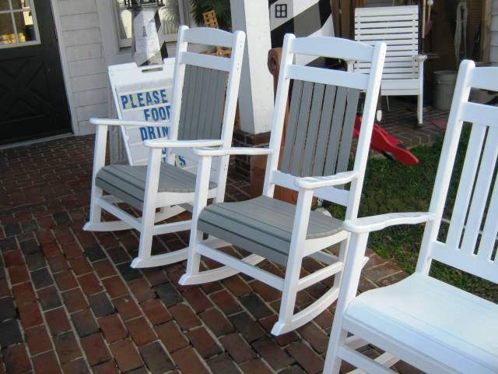  Porch Rockers | $299  Black or White Only | $339  All Other Colors
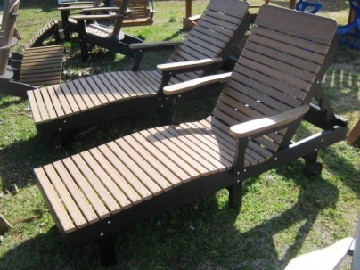  Chaise Lounge | $499 | $549

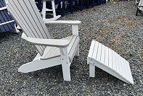  Ottoman | $99 | $119
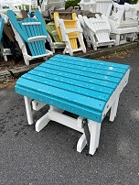  Glider Ottoman | $199 | $219
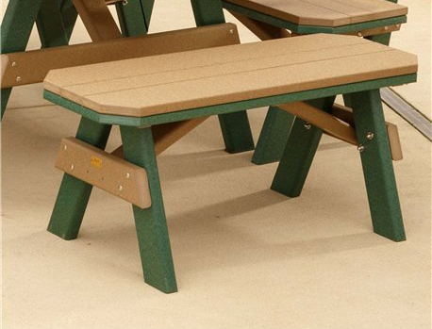  Benches | 78” $329  66” $309  58” $299  54” $279  42” $239  28” $199 | 78” $349  66” $329  58” $319  54” $299  42” $259  28” $219

Note: Premium 2 color items with black as the
secondary color are standard price.

 | Seat Height | Table Height
Dining | 18” | 30”
Café | 24” | 36”
Bar | 30” | 42”
Side Table |  | 21”
Side Table Café |  | 30”

Order Times
4 – 6 Weeks (may be more in prime season)
Any Rollback item up to 16 weeks

